THE SKY IS YOURS: ZENITH’S NEW “PILOT” COLLECTION TAKES OFF AT WATCHES & WONDERS 2023

The dream of taking on the open skies. The pursuit of liberty to rise above and gain a new perspective. The sky is yours, and it’s calling to reach your star. ZENITH’s fascination with the world of aviation goes as far back as the late 19th century, when the Manufacture’s founder Georges Favre-Jacot believed that mankind was on the verge of finally conquering the skies – and that ZENITH should be there alongside the brave pioneers who saw a world of freedom and infinite possibilities far above the horizon. In 1888, ZENITH filed a trademark for the French term “Pilote”, followed by the English version “Pilot” in 1904. In the years that followed, ZENITH would become one of the preeminent makers of specialized watches and dashboard instruments for pilots. Among the most notable of its countless adopters was Louis Blériot, who made history by making the first flight across the English Channel in 1909. Today, ZENITH continues to uphold and build upon this unparalleled heritage with the latest generation of the Pilot collection.

Taking on many forms over the years in a balancing act between heritage and modernism, the ZENITH Pilot collection is the Manufacture’s most long-standing line, and one that never ceases to beguile seasoned watch aficionados as well as avid aviation enthusiasts. The latest chapter caters to the pilot spirit in each of us, seeking the freedom to dream and the space to constantly rise above our limits and the world around us.

Entirely redesigned from scratch, the all-new Pilot collection foregoes the vintage aesthetic for something that draws inspiration from the entire span of aviation – past and present. It is imbued with all the essential features of durability, legibility and intuitiveness, respecting the codes of Pilot watches that ZENITH largely defined over a century ago with some of the earliest recorded aviator clocks and dashboard instruments, now revisited in a more contemporary context with some added ZENITH flair and understated nods to the world of aviation.

Pilot Automatic
The template for the new generation of ZENITH Pilot watches, the Pilot Automatic revisits the collection’s aesthetic codes in an outstanding silhouette full of subtle details. Crafted in a 40mm case in either stainless steel or black ceramic, the Pilot Automatic features an entirely new case design with a distinct flat-top round bezel fixed on top of the rounded case. In the steel version, the surfaces are vertically satin-brushed with polished chamfers, while the black ceramic version is entirely microblasted for a stealthy matte finish. The oversized crown, a defining feature of Pilot watches, takes on a more modern, angular form, while remaining easy to operate – even with gloves on.

The black opaline dial, with its horizontal grooves, mimics the look of corrugated metal sheets that make up the fuselage of many older aircrafts. The oversized luminescent Arabic numerals, a signature feature of ZENITH Pilot watches and dashboard instruments since the early 1900s, take on a more modern font and are applied as metal markers filled with white Super-LumiNova. At 6 o’clock above the date window, the luminescent hour marker takes the form of a flat white line, recalling the artificial horizon instrument in plane. Here, it allows the wearer to instantly understand the orientation of the watch and read the time without second-guessing. The dial is signed “Pilot”, as ZENITH remains the first and only brand to hold the rights to mark its dials with the term.

Visible through the sapphire display back, the Pilot Automatic is powered by the El Primero 3620 high-frequency manufacture movement, which delivers a power reserve of 60 hours when fully wound. The winding mechanism’s open and blackened oscillating weight recalling the archetypal and essential “artificial horizon” dashboard instrument, which informs the pilot of the aircraft’s orientation relative to the Earth's horizon.

The supplied straps are also perfectly matched to the different characters of the two versions of the Pilot Automatic: The black ceramic version is delivered on a stealthy black cordura-effect rubber strap with a newly designed folding clasp developed specifically for the Pilot, as well as a more utilitarian khaki cordura-effect rubber strap. The steel model is also fitted on the same black cordura-effect rubber strap, but its second strap is crafted in brown calfskin leather, recalling typical vintage aviator’s paraphernalia like the flight jacket, gloves and hat. The straps can be easily swapped with the quick-release mechanism integrated directly into the back of the straps, requiring no tools to detach from the spring bars holding them in place.

Pilot Big Date Flyback
The ZENITH Pilot collection simply wouldn’t be complete without a chronograph reference. And for this latest iteration, ZENITH has gone a step further by developing a new version of its El Primero 3600 calibre, with a host of new functions that have been specifically conceived for the Pilot.

The Pilot Big Date Flyback comes in two distinct versions, both in a 42.5mm case. The stainless steel version takes a page from one of the most distinguished El Primero Flyback chronographs, the aptly named “Rainbow Flyback”. The chronograph’s minutes totalizer is done in alternating colours to more easily distinguish between the five-minute marks. The central chronograph seconds as well as the chronograph minutes hands are done in a bright orange tone, another nod to the iconic El Primero Rainbow from 1997. The black ceramic version takes on an achromatic, utilitarian look with luminescent white markers and hands contrasting boldly against the opaline black corrugated dial.

In terms of performance, the new El Primero 3652 automatic high-frequency chronograph calibre integrates two functions to the 5Hz chronograph that are a perfect fit for the Pilot: the big date and the flyback function. Beyond its easy readability, the oversized date display in the Pilot Big Date Flyback features a next-gen patented compliant mechanism that advances and stabilizes both of the big date’s wheels in less than 0.03 seconds. Originally conceived for aviators who wore thick sheepskin gloves, the flyback function allows the chronograph function to be reset to zero and restarted by a single push of a button, simplifying the pilot’s operations and offering the possibility to record consecutive times without stopping. The El Primero chronograph calibre with its “artificial horizon” rotor is visible through the display back. The Pilot Big Date Flyback in ceramic is delivered with black and khaki cordura-effect rubber, while the steel version comes with a black cordura-effect rubber strap and a brown leather strap. All the straps come with an integrated quick-release mechanism for easy swapping without tools.

Capturing the spirit of the aviation pioneers who set their sights far beyond the horizon, the new Pilot collection is a call to chase your dreams – no matter how far or how high. The sky is yours. The time to reach your star is now.

ZENITH: TIME TO REACH YOUR STAR.

ZENITH exists to inspire individuals to pursue their dreams and make them come true – against all odds. Since its establishment in 1865, ZENITH became the first vertically integrated Swiss watch manufacture, and its watches have accompanied extraordinary figures that dreamt big and strived to achieve the impossible – from Louis Blériot’s history-making flight across the English Channel to Felix Baumgartner’s record-setting stratospheric free-fall jump. Zenith is also highlighting visionary and trailblazing women by celebrating their accomplishments and creating the DREAMHERS platform where women share their experiences and inspire others to fulfil their dreams.

With innovation as its guiding star, ZENITH exclusively features in-house developed and manufactured movements in all its watches. Since the creation of the El Primero in 1969, the world’s first automatic chronograph calibre, ZENITH has gone on to master high-frequency precision and offers time measurements in fractions of a second, including 1/10th of a second in the Chronomaster collection and 1/100th of a second in the DEFY collection. Because innovation is synonymous with responsibility, the ZENITH HORIZ-ON initiative affirms the brand's commitments to inclusion & diversity, sustainability and employee wellbeing. ZENITH has been shaping the future of Swiss watchmaking since 1865, accompanying those who dare to challenge themselves and reach new heights. The time to reach your star is now.

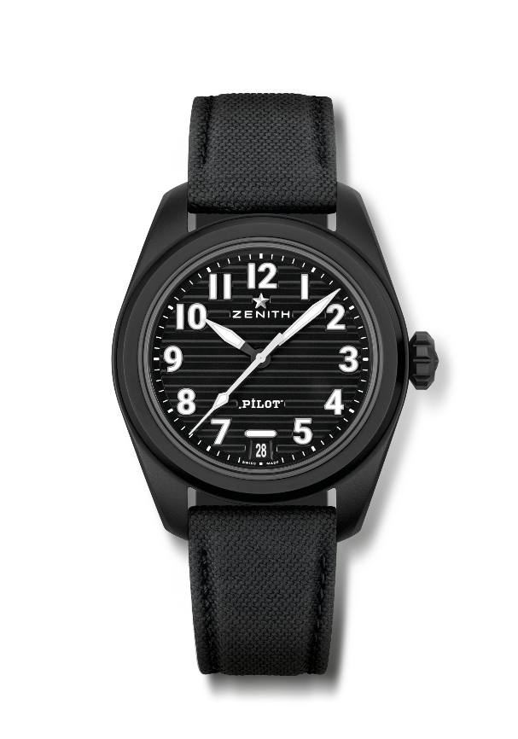
PILOT AUTOMATIC
Reference: 49.4000.3620/21.I001

Key points: El Primero 3-hands watch. High frequency movement (5Hz). Fully interchangeable strap system.
Movement: El Primero 3620, automatic
Frequency 36,000 VpH (5 Hz)
Power reserve approx. 60 hours
Functions : Hours and minutes in the centre. Central seconds hand. Date indication at 6 o'clock.
Finishes: Special "Pilot artificial horizon" black oscillating weight
Price 9500 CHF
Material: Black microblasted ceramic
Water resistance: 10 ATM
Case: 40mm
Dial: Black with horizontal grooves
Hour markers: Applied arabic numerals in SuperLuminova SLN C1
Hands : Black & white with SLN C1
Bracelet & Buckle: Comes with 2 straps: Black cordura effect rubber strap and a khaki cordura effect strap. Steel with black PVD coating triple folding clasp.

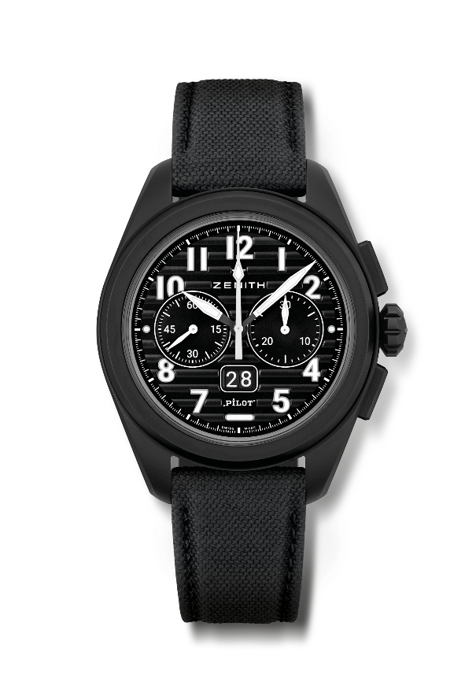
PILOT BIG DATE FLYBACK
Reference: 49.4000.3652/21.I001

Key points: Automatic El Primero column-wheel chronograph with flyback function. Patented Big Date at 6 o'clock. Instanteanous Big Date jump in 0.007 sec (0.02 for discs jump & stabilization). Fully Interchangeable strap system
Movement: El Primero 3652, automatic
Frequency 36,000 VpH (5 Hz)
Power reserve approx. 60 hours
Functions : Hours and minutes in the centre. Small seconds at 9 o'clock
Instantaneous Big Date at 6 o'clock. Flyback Chronograph. 30-minute counter at 3 o'clock
Finishes: Special "Pilot artificial horizon" black oscillating weight
Price 13400 CHF
Material: Black microblasted ceramic
Water resistance: 10 ATM
Case: 42.5mm
Dial: Black with horizontal grooves
Hour markers: Applied arabic numerals in SuperLuminova SLN C1
Hands : Black & white with SLN C1
Bracelet & Buckle: Comes with 2 straps: Black cordura effect rubber strap and a khaki cordura effect strap. Steel with black PVD coating triple folding clasp.

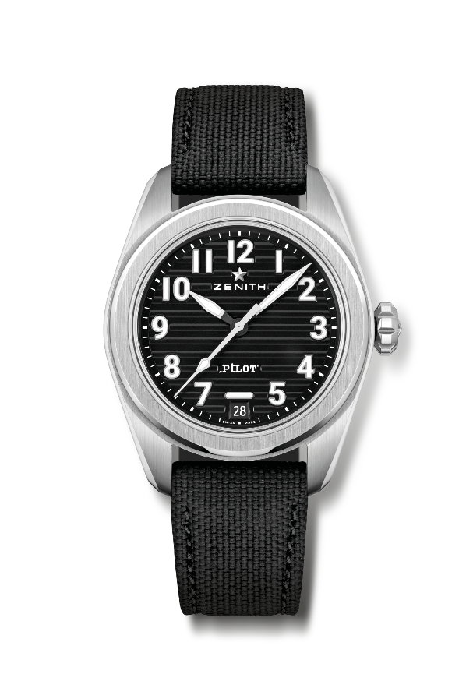
PILOT AUTOMATIC
Reference: 03.4000.3620/21.I001

Key points: El Primero 3-hands watch. High frequency movement (5Hz). Fully interchangeable strap system.
Movement: El Primero 3620, automatic
Frequency 36,000 VpH (5 Hz)
Power reserve approx. 60 hours
Functions : Hours and minutes in the centre. Central seconds hand. Date indication at 6 o'clock.
Finishes: Special "Pilot artificial horizon" black oscillating weight
Price 7500 CHF
Material: Stainless Steel
Water resistance: 10 ATM
Case: 40mm
Dial: Black with horizontal grooves
Hour markers: Applied arabic numerals in SuperLuminova SLN C1
Hands : Black & white with SLN C1
Bracelet & Buckle: Comes with 2 straps: Black cordura effect rubber strap and a Brown calfskin leather strap. Steel triple folding clasp.

PILOT BIG DATE FLYBACK
Reference: 03.4000.3652/21.I001
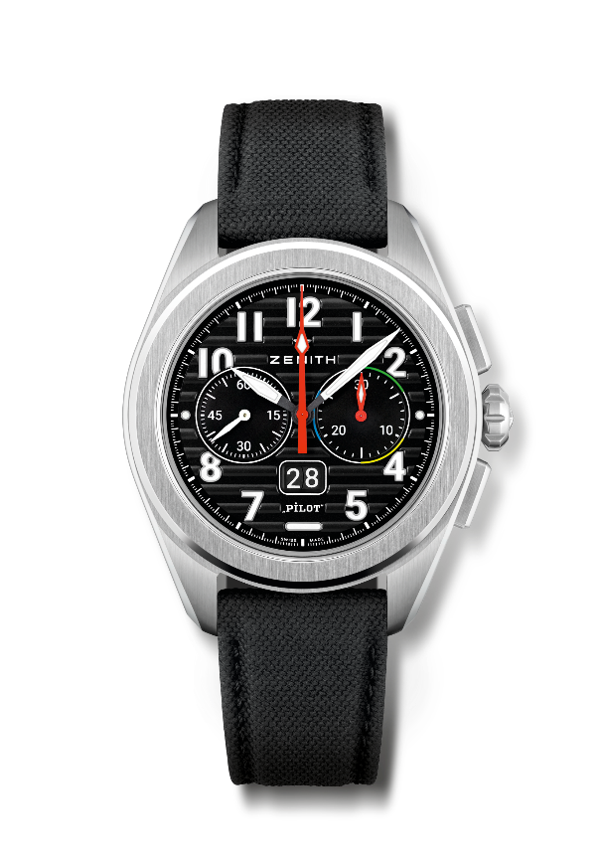
Key points: Tribute to the 1997 first El Primero Flyback movement & Model : the Rainbow Automatic El Primero column-wheel chronograph with flyback function. Patented Big Date at 6 o'clock. Instanteanous Big Date jump in 0.007 sec (0.02 for discs jump & stabilization). Fully Interchangeable strap system.
Movement: El Primero 3652, automatic
Frequency 36,000 VpH (5 Hz)
Power reserve approx. 60 hours
Functions : Hours and minutes in the centre. Small seconds at 9 o'clock
Instantaneous Big Date at 6 o'clock. Flyback Chronograph. 30-minute counter at 3 o'clock
Finishes: Special "Pilot artificial horizon" black oscillating weight
Price 11400 CHF
Material: Stainless steel
Water resistance: 10 ATM
Case: 42.5mm
Dial: Black with horizontal grooves
Hour markers: Applied arabic numerals in SuperLuminova SLN C1
Hands : Black & white with SLN C1
Bracelet & Buckle: Comes with 2 straps: Black cordura effect rubber strap and a Brown calfskin leather strap. Steel triple folding clasp.

