ZENITH PRESENTS THE DEFY EXTREME E 2023 LIMITED EDITION AT
“HYDRO X PRIX” RACE IN SCOTLAND

Scotland, May 11, 2023: Ahead of Extreme E’s Hydro X Prix in Scotland, ZENITH unveils this season’s DEFY Extreme E limited edition watch, crafted entirely in carbon fibre and featuring Extreme E’s official “Vital Green” colour.

For the third Season of Extreme E, ZENITH has created the lightest iteration of its groundbreaking 1/100th of a second chronograph to date: The DEFY Extreme E edition. Combining performance-centric materials and a high-frequency chronograph movement capable of accurately measuring elapsed time to an astounding level of precision, the DEFY Extreme E edition has also been conceived around the values of sustainability shared by Extreme E and ZENITH’s HORIZ-ON initiative of CSR objectives and commitments. It features brightly coloured accents in Extreme E’s signature “Vital Green” tone as a message of awareness and action on climate change, as well as recycled and upcycled parts from the actual races incorporated in the strap and packaging.

On this latest ZENITH special edition created for Extreme E, CEO Julien Tornare shared: “This is the third year that Extreme E has been championing the causes of sustainability and climate change awareness, which are central to ZENITH’s HORIZ-ON CSR initiative. We’re honoured to be able to continue supporting Extreme E as we have from the very beginning, as we truly consider it to be the future of rally racing. The DEFY Extreme E edition commemorates this with an all-carbon construction, a first for the DEFY Extreme line. We’re thrilled to be able to launch it here in Scotland with our friends and partners.”

ZENITH has made its most rugged 1/100th of a second chronograph even lighter while retaining its inherent toughness in the DEFY Extreme E edition. Tried and tested in some of the most extreme conditions and environments that Extreme E has provided, the DEFY Extreme E edition is the first model in the collection to be crafted entirely in lightweight yet tough carbon fibre – including the pushers and their protective elements. The watch weighs only 96 grams, including the strap and triple-folding clasp – also in carbon fibre.

The dashboard of this hardy chronograph is an open multi-layered dial, consisting of tinted sapphire crystal elements and embellished with Extreme E’s official “Vital Green” colour accents, a subtle reminder of the championship’s core value of sustainability. Partially visible through the open dial as well as the sapphire case back is the world’s fastest automatic high-frequency chronograph calibre in production, offering 1/100th of a second time measurements by means of two independent escapements beating at the rate of 5Hz (36’000 VpH) for the timekeeping part and 50Hz (360’000 VpH) for the chronograph function.

Highlighting the themes of sustainability and environmental awareness the DEFY Extreme E edition is delivered with a rubber strap infused with materials of upcycled Continental CrossContact tires that were used in the first season’s races. Matching the Extreme E Vital Green accents on the dial, the Velcro strap features a black rubber central element surrounded by green cordura-effect rubber. The DEFY Extreme E edition is delivered with two additional straps in black rubber and black Velcro, which can be easily swapped without any tools by using the case back’s ingenious and intuitive quick strap-change mechanism.

The DEFY Extreme E edition is delivered in a suitably sturdy waterproof and crushproof watch case inspired by the extreme conditions of the rally, incorporating various upcycled elements from the side-lines of the first Season’s races. The case’s lid coating is made from E-grip recycled tires, while the plate covering is made from parts of an Extreme E racing tarpaulin.
Made in a limited edition of 100 pieces, the DEFY Extreme E edition is available exclusively at ZENITH physical and online boutiques around the world.

Hydro X Prix
For the second race of the 2023 Season, Extreme E is bringing the teams to Dumfries and Galloway in the southwest of Scotland. Symbolic of the need to spread awareness about climate change and find innovative solutions, the race will take place in a former opencast coal mine site, which is about to undergo the next phase of its major transformation into a Pumped Storage Hydropower (PSH) plant and wind farm. It is against this poignant backdrop and surrounded by partners and friends of the brand, including Carl Cox who will DJ at the post-race party aboard Extreme E’s St Helena ship, that ZENITH is unveiling the latest DEFY Extreme E special edition watch.

ZENITH: TIME TO REACH YOUR STAR.

ZENITH exists to inspire individuals to pursue their dreams and make them come true – against all odds. Since its establishment in 1865, ZENITH became the first vertically integrated Swiss watch manufacture, and its watches have accompanied extraordinary figures that dreamt big and strived to achieve the impossible – from Louis Blériot’s history-making flight across the English Channel to Felix Baumgartner’s record-setting stratospheric free-fall jump. Zenith is also highlighting visionary and trailblazing women by celebrating their accomplishments and creating the DREAMHERS platform where women share their experiences and inspire others to fulfil their dreams.

With innovation as its guiding star, ZENITH exclusively features in-house developed and manufactured movements in all its watches. Since the creation of the El Primero in 1969, the world’s first automatic chronograph calibre, ZENITH has gone on to master high-frequency precision and offers time measurements in fractions of a second, including 1/10th of a second in the Chronomaster collection and 1/100th of a second in the DEFY collection. Because innovation is synonymous with responsibility, the ZENITH HORIZ-ON initiative affirms the brand's commitments to inclusion & diversity, sustainability and employee wellbeing. ZENITH has been shaping the future of Swiss watchmaking since 1865, accompanying those who dare to challenge themselves and reach new heights. The time to reach your star is now.

DEFY EXTREME E EDITION
Reference: 10.9101.9004/60.I200

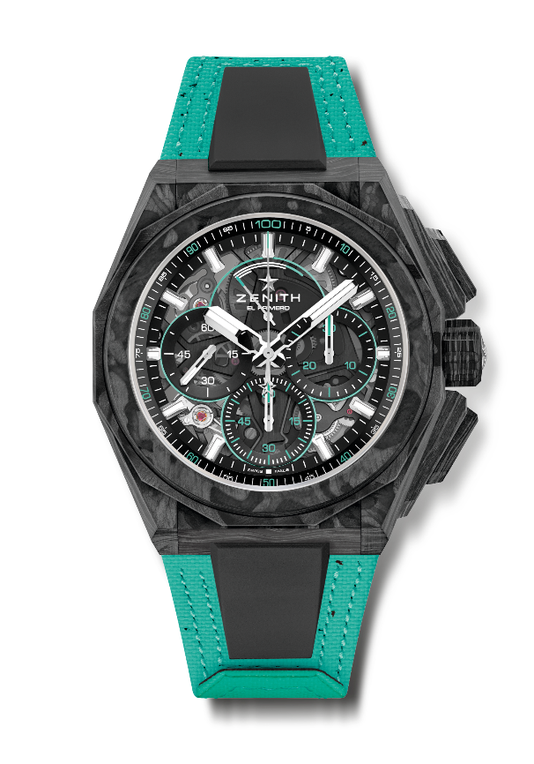
Key points: 1/100th of a second Chronograph movement. Exclusive dynamic signature of one rotation per second for the Chrono hand. Certified Chronometer. Screwed-in crown. 2 straps included : 1 Rubber with folding buckle & 1 Velcro. Sapphire dial. Full Interchangeable strap system
Movement: El Primero 9004, Automatic
Frequency: 1 escapement for the Watch (36,000 VpH - 5 Hz) + 1 escapement for the Chronograph (360,000 VpH – 50 Hz)
Power reserve approx. 50 hours
Functions: Hours and minutes in the centre. Small seconds at 9 o’clock. 1/100th of a second Chronograph: Central chronograph hand that makes one turn each second / 30-minute counter at 3 o'clock / 60-second counter at 6 o'clock / Chronograph power-reserve indication at 12 o'clock
Finishes: Black colored main plate on movement + Special black colored oscillating weight with satined finishings
Price 29900 CHF
Material: Full Carbon
Water resistance: 20 ATM
Case: 45mm
Dial: Tinted sapphire with three black-coloured counters
Hour markers: Rhodium-plated, faceted and coated with SuperLuminova SLN C1
Hands: Rhodium-plated, faceted and coated with SuperLuminova SLN C1
Bracelet & Buckle: Black Rubber. Comes with Vital green Velcro (recycled tires) and carbon triple folding clasp.

