ZENITH LAUNCHES NEW DEFY SKYLINE SKELETON BOUTIQUE EDITION WITH TOUCHES OF GLEAMING GOLD

Le Locle, June 01, 2023 – Expanding on the DEFY Skyline Skeleton that made its debut at the start of the year, ZENITH adds contrasting tones of grey and gold for the Boutique Edition of the world’s first and only skeleton watch to feature a 1/10th of a second indicator.

Far more than an openworked watch, the DEFY Skyline Skeleton brings forth an entirely new design language to the world of skeleton watches. Keeping with the enduring DEFY legacy of sturdy and singularly futuristic timekeepers that began in 1969, the DEFY Skyline collection was conceived for an ever-fast-moving world where every fraction of a second can be a decisive one. Now, the DEFY Skyline Skeleton takes on a new chromatic palette of grey and silver with golden highlights as a boutique-exclusive edition.

Drawing inspiration from modern cityscapes where structures and light are bound in a constantly moving interplay, the DEFY Skyline Skeleton seamlessly integrates the open dial with an openworked version of the El Primero high-frequency automatic. A work of perfect symmetry seldom found in skeleton watches, the open dial takes on the form of a four-pointed stars, recalling the ZENITH “double Z” logo of the 1960s. For the Boutique Edition, the dial takes on a silvery-grey colour, with a darker chapter ring featuring applied gold-plated baton hour markers filled with Super-LumiNova and matching hands for effortless legibility. A constantly running 1/10th of a second counter at 6 o’clock makes steady jumps in fixed increments, completing one revolution every 10 seconds. This unprecedented feature is unique to the new generation of the El Primero automatic high-frequency calibre.

An evolution of the unique octagonal geometry established by the earliest DEFY wristwatch models of the 1960s, the angular steel case of the DEFY Skyline Skeleton retains the same DNA of robustness and durability as its predecessors while bringing an edgier and more architectural aesthetic. The 41mm stainless steel case with sharply defined edges is topped by a faceted bezel, inspired by those from early DEFY models and reimagined with twelve sides that are positioned as extensions to the hour markers. With an emphasis on performance in the largest possible range of activities and situations, the screw-down crown emblazoned with the star emblem provides a water-resistance of 10 ATM (100 metres).

Visible through the open dial as well as the sapphire display back is the openworked version of the high-frequency automatic El Primero calibre, the 3620 SK. Built with a similar architecture as the El Primero 3600 1/10th of a second chronograph, this automatic manufacture movement drives the 1/10th of a second hand directly from the escapement, which beats at 5Hz (36’000 VpH), thus making it a “natural” fraction-of-a-second indication. It is also endowed with a stop-second mechanism for precise time-setting. Efficient in its performance, the automatic winding mechanism with bi-directional rotor with a star motif delivers a power reserve of approximately 55 hours. For the Boutique edition of the DEFY Skyline Skeleton, the movement is finished in a luminous rhodium grey tone.

The DEFY Skyline Skeleton Boutique Edition is available exclusively at ZENITH physical and online boutiques around the world.

ZENITH: TIME TO REACH YOUR STAR.

ZENITH exists to inspire individuals to pursue their dreams and make them come true – against all odds. Since its establishment in 1865, ZENITH became the first vertically integrated Swiss watch manufacture, and its watches have accompanied extraordinary figures that dreamt big and strived to achieve the impossible – from Louis Blériot’s history-making flight across the English Channel to Felix Baumgartner’s record-setting stratospheric free-fall jump. Zenith is also highlighting visionary and trailblazing women by celebrating their accomplishments and creating the DREAMHERS platform where women share their experiences and inspire others to fulfil their dreams.

With innovation as its guiding star, ZENITH exclusively features in-house developed and manufactured movements in all its watches. Since the creation of the El Primero in 1969, the world’s first automatic chronograph calibre, ZENITH has gone on to master high-frequency precision and offers time measurements in fractions of a second, including 1/10th of a second in the Chronomaster collection and 1/100th of a second in the DEFY collection. Because innovation is synonymous with responsibility, the ZENITH HORIZ-ON initiative affirms the brand's commitments to inclusion & diversity, sustainability and employee wellbeing. ZENITH has been shaping the future of Swiss watchmaking since 1865, accompanying those who dare to challenge themselves and reach new heights. The time to reach your star is now.

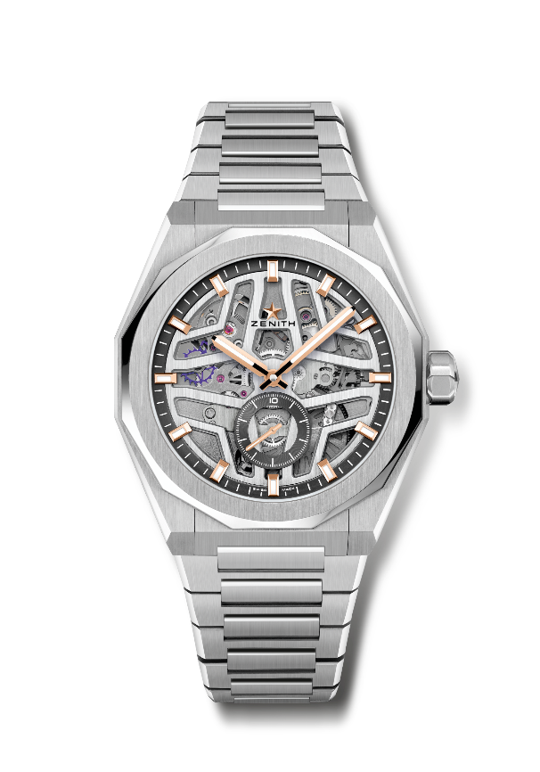
DEFY SKYLINE SKELETON BOUTIQUE EDITION
Reference: 03.9300.3620/80.I001

Key points: El Primero 3-hand watch. High frequency indication: 1/10th of a second. Subdial at 6 o'clock. Silicon escape-wheel and lever. Screwed-in crown. Full Interchangeable strap system.
Movement: El Primero 3620 SK, Automatic
Frequency: 36’000 VpH – 5Hz
Power reserve: approx. 55 hours
Functions: Hours and minutes in the centre. 1/10th of a second counter at 6 o'clock
Finishes: Special oscillating weight with satined finishings
Price: 10900 CHF
Material: Stainless steel
Water resistance: 10 ATM
Case: 41mm
Dial: Openworked
Hour markers: Gold-plated, faceted and coated with SuperLuminova SLN C1
Hands: Gold-plated, faceted and coated with SuperLuminova SLN C1
Bracelet & Buckle: Stainless steel bracelet. 2nd bracelet Black Rubber with starry sky pattern. Stainless steel folding clasp.

