ZENITH CONTINUES ITS SUPPORT FOR THE GLOBAL FIGHT AGAINST BREAST CANCER WITH THE CHRONOMASTER ORIGINAL PINK
“UNIQUE PIECE FOR SUSAN G. KOMEN®”

Today, ZENITH is proud to announce its continued support for the world’s leading breast cancer organization with a special Chronomaster Original Pink “Unique Piece for Susan G. Komen®”- 100% of the proceeds will benefit the organization.

ZENITH and Phillips are thrilled to present this unique Chronomaster Original Pink timepiece with 100% of proceeds supporting Susan G. Komen – the world’s leading breast cancer organization—a worthy cause that deeply resonates with the ZENITH Manufacture. The auction will take place from June 10-11, 2023, in person in New York City or online. Additional information and a link to the auction can be found here https://www.zenith-watches.com/en_us/news/phillips-auction-2023

The auctioning of this singular piece in partnership with Komen and Phillips marks another step in which ZENITH is actively rallying behind the cause of Breast Cancer Awareness. It follows the launch of the Chronomaster Original Pink edition in October 2022, from which a portion of the sales proceeds were donated to Susan G. Komen®, as well as the MEET THE DREAMHERS event held in Singapore, that bolstered the Manufacture’s commitment to fight breast cancer and support one of the world’s leading organizations.

Women’s empowerment is one of the main pillars of the ZENITH HORIZ-ON initiative, driving many of the brand’s commitments and actions. For many years, ZENITH has been working to raise awareness about breast cancer, an indiscriminate disease that affects one in every eight women and impacts countless lives around the world. Whether through education and promoting the practice of screening or supporting organisations that are ceaselessly searching for a cure, ZENITH’s support of Komen further solidifies its commitment to reaching more women and raising global awareness about breast cancer by offering access to education, hope and support. A new development of this growing partnership with Komen is the launch of “Time to Make an Impact”, an initiative that highlights the stories of breast cancer survivors and their supporters to amplify their voices to the millions of people who turn to the organization for support and education.

ZENITH’s CEO Julien Tornare shared: “Supporting Komen, with its rapport and incredible impact, is a partnership of great significance for ZENITH. The Chronomaster Original Pink unique piece will help fund impactful research and support for patients undergoing treatment, a cause we are proud and eager to be a part of over the coming years.”

Komen’s SVP of Corporate Partnerships, Sarah Rosales, added: “ZENITH has been an incredible advocate and supporter for the breast cancer community for many years, and when two organizations come together under one shared mission, we can truly be unstoppable. With ZENITH’s partnership, creating a world without breast cancer becomes a more achievable reality every day, and we’re beyond grateful for their support.”

The Chronomaster Original Pink, Unique Piece for Susan G. Komen is a one-of-a-kind edition with diamond-set lugs similar to the brand’s iconic A386. Crafted in a 38mm steel case and equipped with the latest generation of the El Primero automatic high-frequency chronograph calibre with 1/10th of a second measurement, the Chronomaster Original Pink stands out with its striking metallic pink dial, honouring the color globally associated with breast cancer awareness. The piece comes with the offer of an additional strap of the winning bidder’s choosing as well as a certificate stating the watch’s uniqueness. This is a wonderful opportunity to support Komen and own a unique ZENITH El Primero.

As the world’s leading nonprofit breast cancer organization, Komen is committed to supporting those affected by breast cancer today, while tirelessly searching for tomorrow’s cures. Komen has an unmatched, comprehensive 360-degree approach to fighting this disease across all fronts and supporting millions of people in the U.S. and in countries worldwide. Komen advocates for patients, drives research breakthroughs, improves access to high-quality care, offer direct patient support and empower people with trustworthy information.

Beyond the creation of this unique edition, ZENITH looks forward to supporting Susan G. Komen® over the coming years, actively participating in fundraising events, charity auctions and other initiatives. ZENITH also looks forward to hosting representatives from Susan G. Komen® at DREAMHERS events around the world. The brand’s unique platform which offers visionary, independent, and inspirational women a space to share their voices and passions, will help grow awareness, share important information and promote good practices related to breast cancer.

ZENITH: TIME TO REACH YOUR STAR.

ZENITH exists to inspire individuals to pursue their dreams and make them come true – against all odds. Since its establishment in 1865, ZENITH became the first vertically integrated Swiss watch manufacture, and its watches have accompanied extraordinary figures that dreamt big and strived to achieve the impossible – from Louis Blériot’s history-making flight across the English Channel to Felix Baumgartner’s record-setting stratospheric free-fall jump. ZENITH is also highlighting visionary and trailblazing women by celebrating their accomplishments and creating the DREAMHERS platform where women share their experiences and inspire others to fulfil their dreams.

With innovation as its guiding star, ZENITH exclusively features in-house developed and manufactured movements in all its watches. Since the creation of the El Primero in 1969, the world’s first automatic chronograph calibre, ZENITH has gone on to master high-frequency precision and offers time measurements in fractions of a second, including 1/10th of a second in the Chronomaster collection and 1/100th of a second in the DEFY collection. Because innovation is synonymous with responsibility, the ZENITH HORIZ-ON initiative affirms the brand's commitments to inclusion & diversity, sustainability and employee wellbeing. ZENITH has been shaping the future of Swiss watchmaking since 1865, accompanying those who dare to challenge themselves and reach new heights. The time to reach your star is now

About Susan G. Komen®
Susan G. Komen® is the world’s leading nonprofit breast cancer organization, working to save lives and end breast cancer forever. Komen has an unmatched, comprehensive 360-degree approach to fighting this disease across all fronts and supporting millions of people in the U.S. and in countries worldwide. We advocate for patients, drive research breakthroughs, improve access to high-quality care, offer direct patient support and empower people with trustworthy information. Founded by Nancy G. Brinker, who promised her sister, Susan G. Komen, that she would end the disease that claimed Suzy’s life, Komen remains committed to supporting those affected by breast cancer today, while tirelessly searching for tomorrow’s cures. Visit komen.org or call 1-877 GO KOMEN. Connect with us on social at www.komen.org/social.

About PHILLIPS
Phillips is a leading global platform for buying and selling 20th and 21st century art and design. With dedicated expertise in the areas of 20th Century and Contemporary Art, Design, Photographs, Editions, Watches, and Jewelry, Phillips offers professional services and advice on all aspects of collecting. Auctions and exhibitions are held at salerooms in New York, London, Geneva, and Hong Kong, while clients are further served through representative offices based throughout Europe, the United States and Asia. Phillips also offers an online auction platform accessible anywhere in the world. In addition to providing selling and buying opportunities through auction, Phillips brokers private sales and offers assistance with appraisals, valuations, and other financial services. Visit www.phillips.com for further information.

CHRONOMASTER ORIGINAL PINK “Unique Piece for Susan G. Komen”
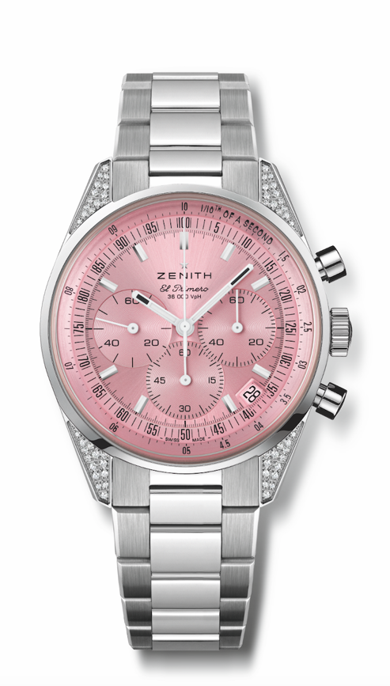
Reference: 16.3201.3600/33.M3200

Movement: Automatic El Primero 3600, with a rare 1/10th of a second chronograph function.

Case No.: 618’481

Material: Stainless steel and diamond set lugs (56 brilliant cut totaling 0.22 cts)

Dial: Pink-toned sunray-patterned

Dimensions: 38 mm Diameter

Bracelet / Strap: Stainless steel bracelet

Clasp / Buckle: Stainless steel folding clasp

Hour-markers: Rhodium-plated, faceted, and coated with SuperLuminova SLN C1

Hands: Rhodium-plated, faceted, and coated with SuperLuminova SLN C1

Price Estimate: $8,000-16,000 USD

